**WEEK 5**

**Microservices with Spring Boot 3 and Spring Cloud**

**Creating Microservices for account and loan**

In this hands on exercises, we will create two microservices for a bank. One microservice for handing accounts and one for handling loans.

Each microservice will be a specific independent Spring RESTful Webservice maven project having it's own pom.xml. The only difference is that, instead of having both account and loan as a single application, it is split into two different applications. These webservices will be a simple service without any backend connectivity.

**Step -1 :-** Create a Directory and a folder Inside it

D:\employee_id\microservices

**Step-2:-** create account folder  
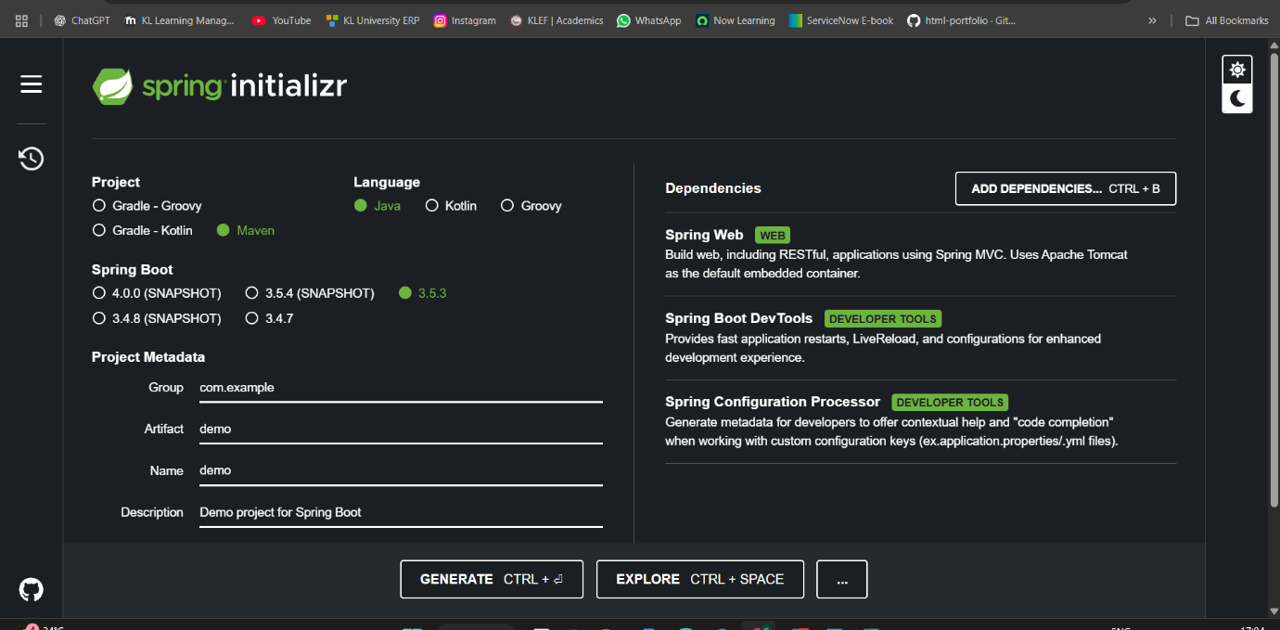

**Step-3:-** Put this Account folder under the below directory D:\employee_id\microservices

**Step-4:- Create AccountController.java** *in com.cognizant.account.controller package*

**package** com.cognizant.account.controller;

**import** java.util.Map;

**import** org.springframework.web.bind.annotation.*;

**import** java.util.HashMap;

@RestController

@RequestMapping("/accounts")

**public** **class** AccountController {

@GetMapping("/{number}")

**public** Map<String, Object> getAccount(@PathVariable String number) {

Map<String, Object> response = **new** HashMap<>();

response.put("number", number);

response.put("type", "savings");

response.put("balance", 234343);

**return** response;

}

}

**Output :-**

**Step- 5 :- Create loan spring project in microservices folder:**

**Step- 6 :- Change port to 8081 in application.properties using:**

server.port=8081

**Step-7:**

**Create LoanController.java in com.cognizant.loan.controller package:**

**package** com.cognizant.loan.controller;

**import** org.springframework.web.bind.annotation.*;

**import** java.util.Map;

**import** java.util.HashMap;

@RestController

@RequestMapping("/loans")

**public** **class** LoanController {

@GetMapping("/{number}")

**public** Map<String, Object> getLoan(@PathVariable String number) {

Map<String, Object> response = **new** HashMap<>();

response.put("number", number);

response.put("type", "car");

response.put("loan", 400000);

response.put("emi", 3258);

response.put("tenure", 18);

**return** response;

}

}

**Output:**

**Now two microservices running on different ports:**

**In local 8080 & 8081**

